ai assisted coding

# Assignment : 9.3 - Documentation Generation: Automatic documentation and code comments

## Pavani Voddepalli

## 2403A52107

## 24BTCAIAI05

**TASK – 1 :** **Write python function to return sum of even and odd numbers in the given list without comments .**

**CODE, OUTPUT & DOC’STRING:**

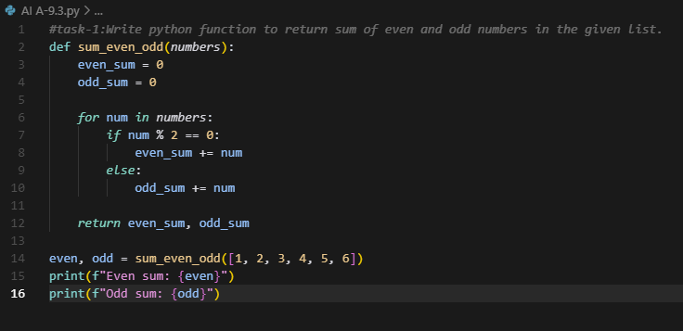

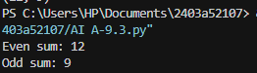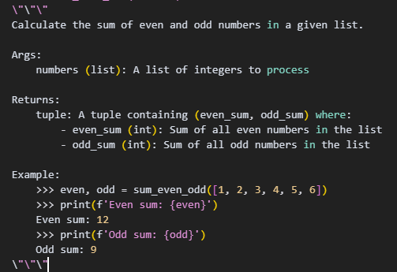

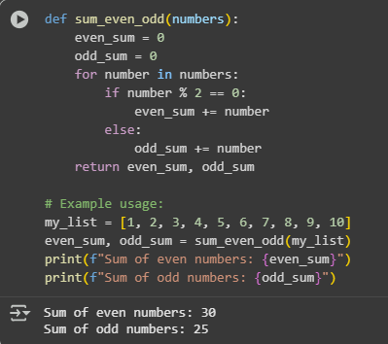

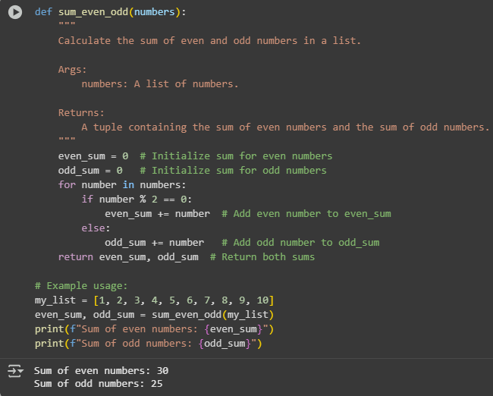

**TASK – 2 : Write python program for sru_student class with attributes like name, roll no.,**

**hostel_status and fee_update method and display_details method with inline comments.**

**CODE DOC’STRING & OUTPUT :**

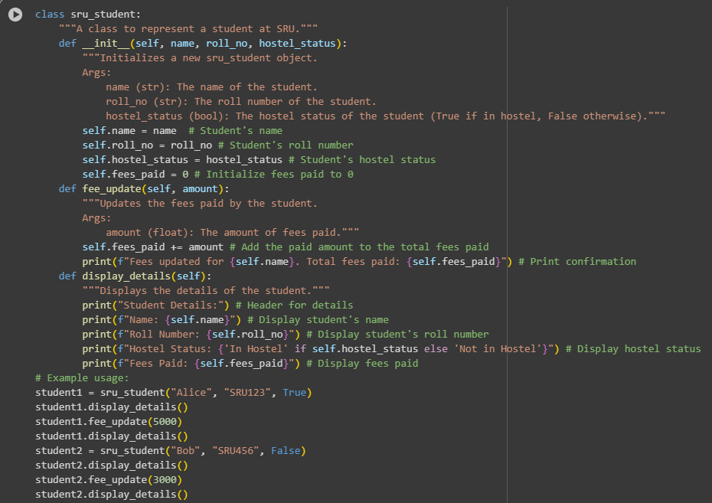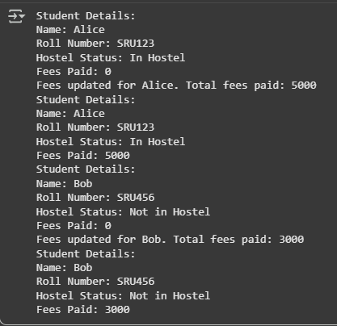

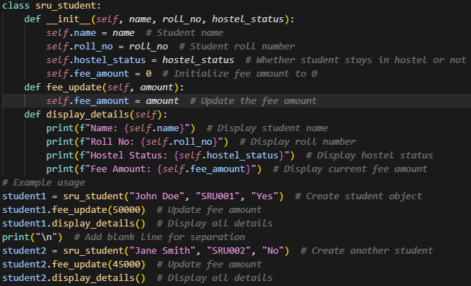

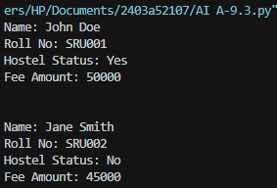

**TASK – 3 : Write a Python script with 3–4 functions (e.g., calculator: add, subtract, multiply,**

**divide) and** **generate a module-level docstring + individual function docstrings.**

**CODE, OUTPUT & DOC’STRING